Chip back potential is the level which bulk silicon is maintained by on-chip connection, or it is the level to which the chip back must be connected when specifically stated below. If no potential is given the chip back should be isolated.

.053”
PAD FUNCTIONS:

- IN₁
- IN₂
- IN₃
- IN₄
- IN₅
- IN₆
- IN₇
- IN₈
- GND (backside)
- COM
- OUT₈
- OUT₇
- OUT₆
- OUT₅
- OUT₄
- OUT₃
- OUT₂
- OUT₁

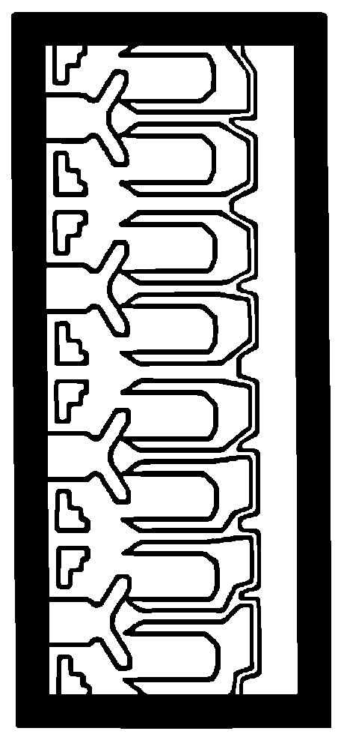
1

2

3

4

5

6

7

8

18

17

16

15

14

13

12

11

10

.123”

Top Material: Al
Backside Material: Si
Bond Pad Size: .004” X .004”
Backside Potential: GND
Mask Ref: 2823

APPROVED BY: DK DIE SIZE .053” X .123” DATE: 4/27/23
MFG: SPRAGUE/ALLEGRO THICKNESS .010” P/N: ULS2823
DG 10.1.2

Rev B, 7/19/02

